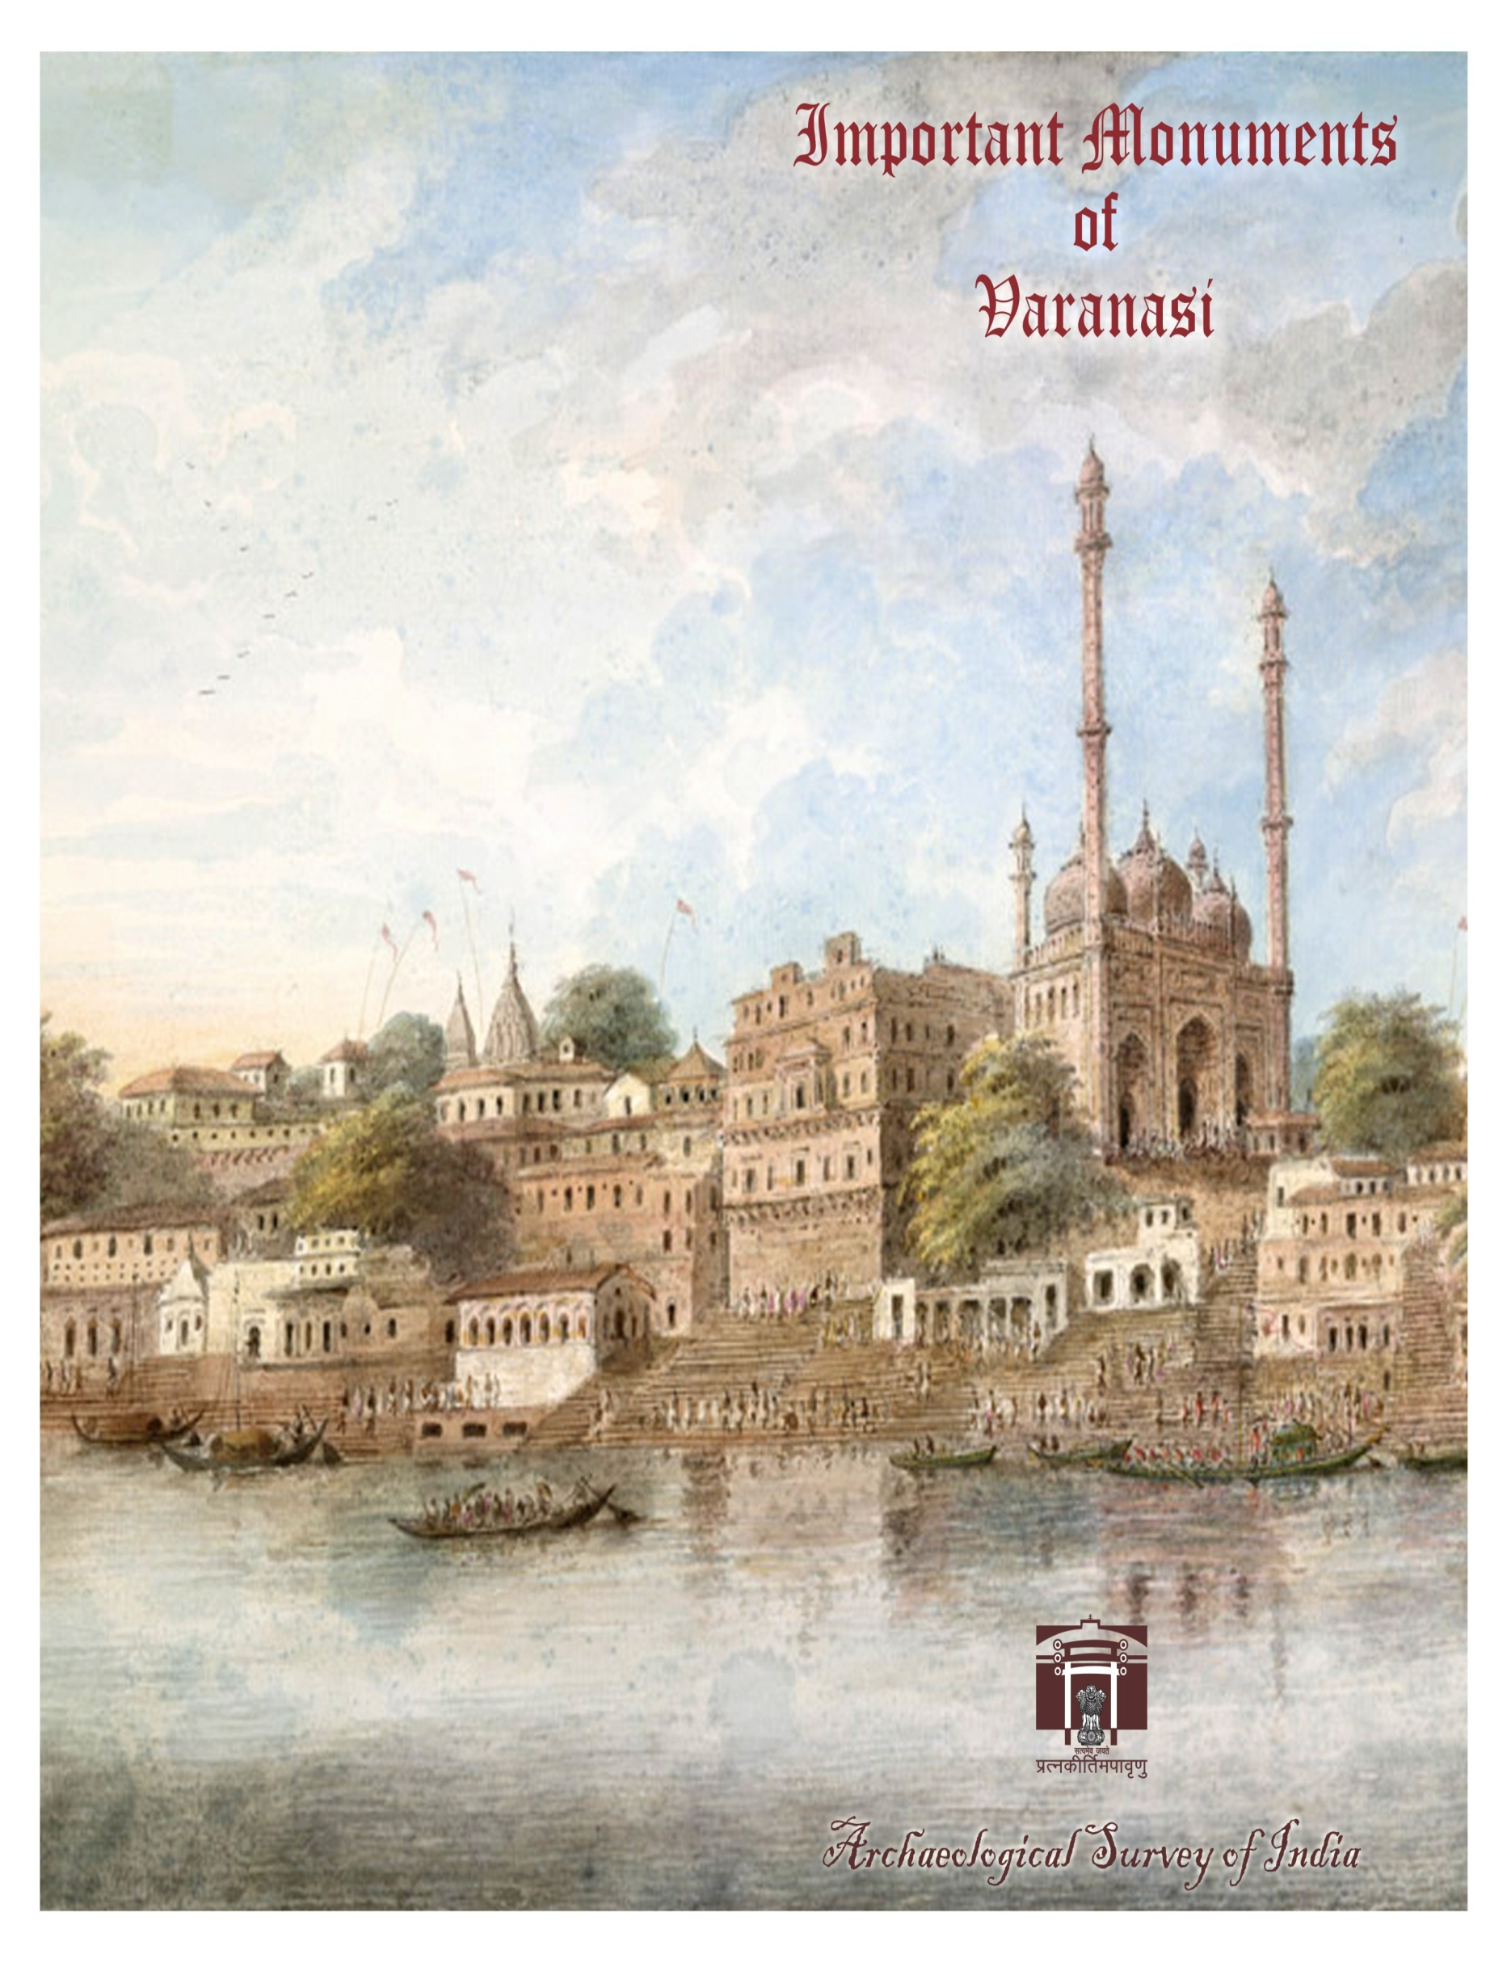
A monument is a type of structure that was explicitly created to commemorate a person or important event, or which has become important to a social group as a part of their remembrance of historic times or cultural heritage, or as an example of historic architecture. The term 'monument' is often applied to buildings or structures that are considered examples of important architectural and/or cultural heritage.
-Wikipedia
Allahabad Sub-Circle

Sl. No. | Name of Monuments / Sites as notified | Locality | Taluk/ District | Type of Monument
1. | Allahabad Fort  Asokan Stone Pillar  Zanana palace | Allahabad  Tehsil- Chayal | Allahabad | Pillar site
2. | Cemeteries at Kydganj | Allahabad  Tehsil- Chayal | Allahabad | Colonial site
3. | KhusruBagh:  1. Enclosure wall & Gateway of KhusruBagh  2. Tomb of BibiTambolan.  3. Tomb of Sultan Khusru.  4. Tomb of Sultan Khusru’s Mother  5. Tomb of Sultan Khusru’s Sister | Allahabad  Tehsil- Chayal | Allahabad | Muslim/Islamic monument
4. | Queen Victoria’s Memorial in Alfred Park. | Allahabad  Tehsil- Chayal | Allahabad | Colonial
5. | Small High Mound, the ancient site of a large Hindu Temple | Bara,  Tehsil-Bara | Allahabad | Mound probably a Temple
6. | The area of the waste land divided by a ravine into two large mounds called “Garha” & “Garhi”. | Bhita,  Tehsil-Bara | Allahabad | Mound
7. | Large stone dwelling house said to have been the residence of the two heroes of Ala & Udal c.8th century A.D. | Chilla,  Tehsil-Bara | Allahabad | Misc.
8. | Standing figure identified by Fuehrer as Buddha Asvaghosha (4.5 feet high) with a five-headed snake canopy and worshipped by the villagers under the name of Srigari Davi. | Deora near Bhita,  Tehsil-Bara | Allahabad | Sculpture
9. | A rock cave on the south face of the top bearing an inscription of three lines of the Indo-Scythian period in red paint with some rude drawings of men & animals. | Ginja Hill,  Tehsil-Bara | Allahabad | Cave – cum- inscriptional site
10. | Ruined Forts of Samudra Gupta & Hansa Gupta. | Jhusi,  Tehsil-Phoolpur | Allahabad | Fort
11. | Cave known as Sita-ki-Rasoi containing an inscription in three lines of the 9th century A.D. | Mankuar,  Tehsil-Bara | Allahabad | Cave – cum- inscriptional site
12. | Extensive mound locally known Hatgauha Dih. | Shiupur,  Tehsil-Soraon | Allahabad | Mound
13. | Garhwa Fort | Sheorajpur  Tehsil-Bara | Allahabad | Fort
14. | Large mound called Surya Bhita | Shringaverpur  Tehsil-Soraon | Allahabad | Fort
15. | Fort attributed to Jay Chandra | Karra,  Tehsil-Sirathu | Kaushambi | Fort
16. | The ancient fortress (representing the ancient Kaushambi) | Kosam  Tehsil-Manjhampur | Kaushambi | Ancient structural remains
17. | Artificial cave in the fane of the hill of Pabhosa | Pabhosa,  Tehsil-Manjhampur | Kaushambi | Cave
18. | Traces of a large brick building on the summit of Pabhosa hill | Pabhosa,  Tehsil-Manjhampur | Kaushambi | Mound
19. | Old Nawabi Mosque. | Akbarpur,  Tehsil – Ambedkar Nagar | Ambedkar Nagar | Muslim/Islamic monument

Faizabad Sub-Circle

Sl. No. | Name of Monuments / Sites as notified | Locality | Taluk/ District | Type of Monument
1. | Extensive brick strewn mounds | Raipur Tikri & Shahgarh,Tehsil –Gauriganj | Amethi (Previously inSultanpurDistt.) | Mound
2. | A group of ruined brick temple of the 10th Cen. locally called Teligarhi. | Bhagupur, Tehsil – Musafirkhana | Amethi (Previously inSultanpurDistt.) | Temple
3. | Three mounds known as Mani-Parbat, Kuber-Parbat & Sugrib Parbat. | Ayodhya, Tehsil – Faizabad | Faizabad | Mound
4. | Bibi Khanam’s Tomb. | Ayodhya, Tehsil – Faizabad | Faizabad | Muslim/Islamic monument
5. | Gulab Bari. | Ayodhya, Tehsil – Faizabad | Faizabad | Muslim/Islamic monument
6. | Tomb of Shuja-ud-Daula. | Ayodhya, Tehsil – Faizabad | Faizabad | Muslim/Islamic monument
7. | Tomb of Bahu-Begum. | Ayodhya, Tehsil – Faizabad | Faizabad | Muslim/Islamic monument
8. | Tomb of Haji Iqbal, Eunach of Sadar Jahan Begum including the mosque & the whole compound enclosing them. | Ayodhya, Tehsil – Faizabad | Faizabad | Muslim/Islamic monument
9. | A mound 20’ high apparently formed of solid brick work where the Prithvinath Lingam & a copper plate grant were found. | Pachran, Tehsil – Gonda | Gonda | Temple
10. | Mound covered with bricks with the ruins of the temple of Asokanath Mahadeva. | Hathili, Tehsil – Tarabganj | Gonda | Temple

Kushinagar Sub-Circle

Sl. No. | Name of Monuments / Sites as notified | Locality | Taluk/ District | Type of Monument
1. | A Conical stupa shaped mound | Amaoni | Deoria | Buddhist sites and stupa sites
2. | Inscribed monolith of rough grey sand stone remains. | Bhagalpur | Deoria | Pillar
3. | An Inscribed stone pillar | Kahaon (ancient Kakubha) | Deoria | Pillar
4. | Two ruined temples (now Jain temples constructed over ancient temples) | Kahaon (ancient Kakubha) | Deoria | Temple
5. | Long low mound of ruins | Khukhundu | Deoria | Mound
6. | Ancient site | Khukhundu & Sajhwar | Deoria | Mound
7. | Ancient site | Rudrapur | Deoria | Mound
8. | High square shaped mound | Rudrapur | Deoria | Mound
9. | Extensive mound | Sohnag | Deoria | Mound
10. | Very high Dih or Mound probably the remains of Buddhist stupa | Tarkulwa | Deoria | Buddhist sites and stupa site
11. | Extensive remains of a very large city | Barhi | Grokhapur | Mound
12. | A series of enormous mounds | Barhiapur or Bhadar Khas | Grokhapur | Mound
13. | Three high conical mounds of brick which are evidently the ruins of stupas | Chaora | Grokhapur | Mound
14. | Ancient site covered with mounds of brick ruins and containing an ancient masonry wall | Gagaha | Grokhapur | Mound
15. | Extensive mound | Gopalpur | Grokhapur | Mound
16. | Large and high mound, the ruins of the ancient Domangarh | Gorakhpur | Grokhapur | Mound
17. | Circular shaped mound and the remains of a stupa | Chhetion | Kushinagar | Mound
18. | Large dih or mound | Chhetion | Kushinagar | Mound
19. | Large flat topped mound of ruins called Jharmatiya or Dharmatiya cultivated land (Private ownership) | Jhamathiya (3.66 mile N-E of Chhetion) | Kushinagar | Mound
20. | A Very large Mound of brick ruins called Asmanpurdih | Asmanpur (3.5 mile south of Chhetion) | Kushinagar | Mound
21. | Mound on the eastern extension of the stupa site at Sl.No.3 | Chhetion | Kushinagar | Mound
22. | Mound of ruins called Sahiya | Sareya ( 3 mile N, NW of Chhetion) | Kushinagar | Mound
23. | Buddhist remains. | Kasia | Kushinagar | Mound
24. | Large mound covered with broken bricks and a few statues | Padrauna | Kushinagar | Mound
25. | Mound of brick ruins | Sahiya | Kushinagar | Mound
26. | Ancient Site and Archaeological Remains | Rudruli | Mahrajganj/ Gorakhpur | Mound
27. | Ancient Site know as Fazil Nagar ka kot | Fazil Nagar | Kushinagar | Mound

Jaunpur Sub-Circle

Sl. No. | Name of Monuments / Sites as notified | Locality | Taluk/ District | Type of Monument
1. | Monuments of Captains Wilsons and Jones and eleven privates of 13th infantry | Azamgarh | Azamgarh | Colonial site
2. | Mutiny monuments | Azamgarh | Azamgarh | Colonial site
3. | Old British Cemetery | Azamgarh | Azamgarh | Colonial site
4. | Ancient site called Garhwa-ka-Kot or Rajbhar-ka-Kot | Garhwa | Azamgarh | Mound
5. | Ancient site measuring 7 acres and 800 links in Khesra No.384 | Garhwa | Azamgarh | Mound
6. | Tomb of Abhiman | Mehnagar | Azamgarh | Muslim/Islamic monument
7. | Inscribed stone pillar | Pakri | Azamgarh | Muslim/Islamic monument
8. | Atala Masjid | Jaunpur | Jaunpur | Muslim/Islamic monument
9. | Cemetery of seven kings of the Sharqui dynasty | Jaunpur | Jaunpur | Muslim/Islamic monument
10. | Jaunpur Fort | Jaunpur | Jaunpur | Fort
11. | Hammam or Turkish bath in the old fort | Jaunpur | Jaunpur | Fort
12. | Jhanjhri Masjid | Jaunpur | Jaunpur | Muslim/Islamic monument
13. | Juma Masjid | Jaunpur | Jaunpur | Muslim/Islamic monument
14. | Khails Muklis or Char Ungli Masjid | Jaunpur | Jaunpur | Muslim/Islamic monument
15. | Khanqah or Tombs of Sharqui kings of Jaunpur and the chamber for the royal mourners | Jaunpur | Jaunpur | Muslim/Islamic monument
16. | Lal Masjid (Lal Darwaza) | Jaunpur | Jaunpur | Muslim/Islamic monument
17. | Qalich Khan ka Maqbara | Jaunpur | Jaunpur | Muslim/Islamic monument
18. | Ruaza of Shah Firoz | Jaunpur | Jaunpur | Muslim/Islamic monument
19. | Stone group of a gigantic lion standing on a small elephant, lying on Akbar’s bridge | Jaunpur | Jaunpur | Muslim/Islamic monument
20. | Tomb of Nawab Ghazi Khan | Jaunpur | Jaunpur | Muslim/Islamic monument-
21. | Gateway of Hazrat Chirag-I-Hind’s palace | Zafrabad | Jaunpur | Muslim/Islamic monument
22. | Sheikh Burhan’s Mosque | Zafrabad | Jaunpur | Muslim/Islamic monument
23. | Walls of the old Kankar fort of Jayachandra | Zafrabad | Jaunpur | Fort

